**Class:** Final Year (Computer Science and Engineering)

**Year:** 2023-24 **Semester:** 1

**Course:** High Performance Computing Lab

## Practical No.10

PRN No : 2020BTECS00049

Name : Siddhi Hagawane

# **Q1: Implement a MPI program to give an example of Deadlock.**

#include "mpi.h"

#include <math.h>

int main(int argc, char **argv) {

MPI_Status status;

int num;

MPI_Init(&argc, &argv);

MPI_Comm_rank(MPI_COMM_WORLD, &num);

double d = 100.0;

int tag = 1;

if (num == 0) {

// synchronous Send

MPI_Ssend(&d, 1, MPI_DOUBLE, 1, tag,

MPI_COMM_WORLD);

MPI_Recv(&d, 1, MPI_DOUBLE, 1, tag,

MPI_COMM_WORLD, &status);

} else {

// Synchronous Send

MPI_Ssend(&d, 1, MPI_DOUBLE, 1, tag,

MPI_COMM_WORLD);

MPI_Recv(&d, 1, MPI_DOUBLE, 1, tag,

MPI_COMM_WORLD, &status);

}

MPI_Finalize();

return 0;

}

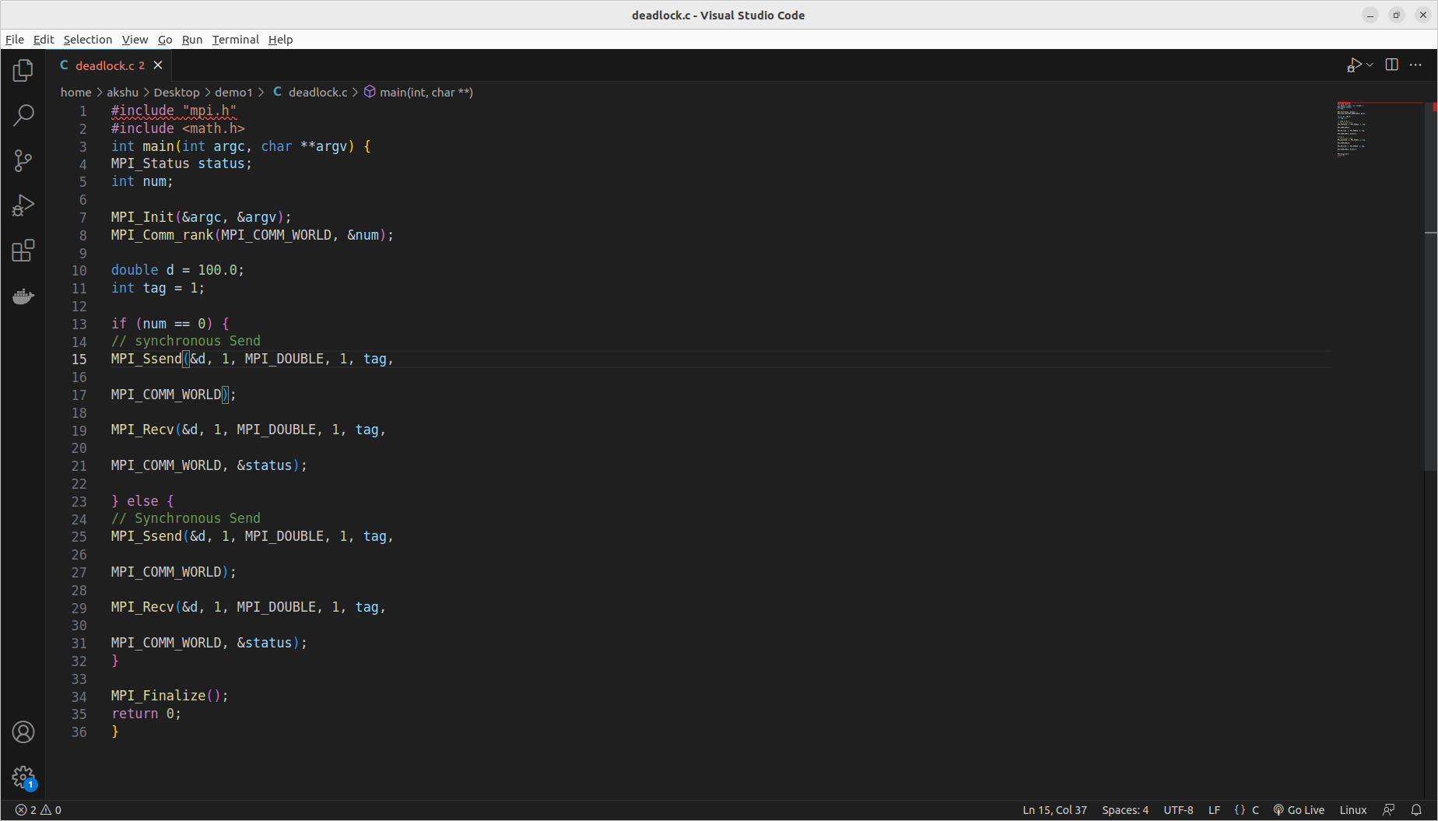

# **Q2. Implement blocking MPI send & receive to demonstrate Nearest neighbor exchange of data in a ring topology.**

**#include "mpi.h"**

#include <stdio.h>

int main(int argc, char **argv) {

int rank;

int num;

MPI_Init(&argc, &argv);

MPI_Comm_size(MPI_COMM_WORLD, &num);

MPI_Comm_rank(MPI_COMM_WORLD, &rank);

MPI_Status status;

double d = 483048.0;

int tag = 1;

// calculating next rank

int rank_next = (rank + 1) % num;

// prev process rank

int rank_prev = rank == 0 ? num - 1 : rank - 1;

if (num % 2 == 0) {

printf("Rank %d: sending to %d\n", rank,

rank_next);

MPI_Send(&d, 1, MPI_DOUBLE, rank_next, tag,

MPI_COMM_WORLD);

printf("Rank %d: receiving from %d\n", rank,

rank_prev);

MPI_Recv(&d, 1, MPI_DOUBLE, rank_prev, tag,

MPI_COMM_WORLD, &status);

} else {

printf("Rank %d: receiving from %d\n", rank,

rank_prev);

MPI_Recv(&d, 1, MPI_DOUBLE, rank_prev, tag,

MPI_COMM_WORLD, &status);

printf("Rank %d: sending to %d\n", rank,

rank_next);

MPI_Send(&d, 1, MPI_DOUBLE, rank_next, tag,

MPI_COMM_WORLD);

}

MPI_Finalize();

return 0;

}

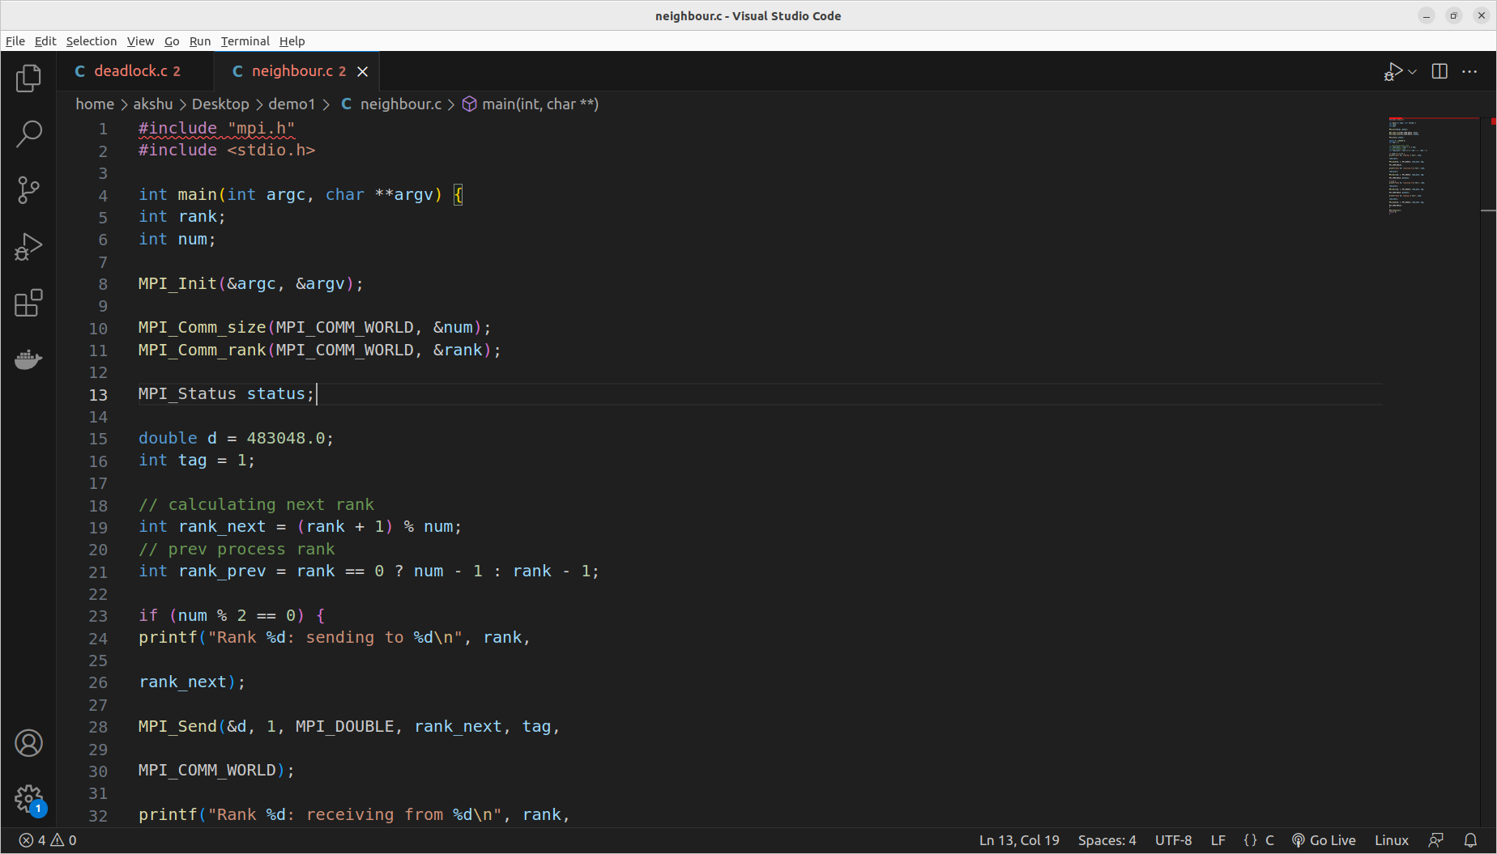

# 

# 

# **Q3. Write a MPI program to find the sum of all the elements of an array A of size**

**n. Elements of an array can be divided into two equals groups. The first [n/2]**

# **elements are added by the first process, P0, and last [n/2] elements the by second process, P1. The two sums then are added to get the final result.**

**#include "mpi.h"**

#include <stdio.h>

#define localSize 1000

int local[1000]; // to store the subarray data comming

// from process 0;

int main(int argc, char **argv)

{

int rank;

int num;

int n = 10;

int arr[10] = {1, 2, 3, 4, 5, 6, 7, 8, 9, 10};

int per_process, elements_received;

MPI_Init(&argc, &argv);

MPI_Comm_size(MPI_COMM_WORLD, &num);

MPI_Comm_rank(MPI_COMM_WORLD, &rank);

MPI_Status status;

// process with rank 0 will divide data among all processes and add partial sums to get final sum

if (rank == 0)

{

int index, i;

per_process = n / num;

if (num > 1) // if more than 1 processes available

{

// divide array data among processes

for (i = 1; i < num - 1; i++)

{

// calculating first index of subarray that need to be send to ith process

index = i * per_process;

// send no of elements and subarray of that length to each process

MPI_Send(&per_process, 1, MPI_INT, i, 0,

MPI_COMM_WORLD);

MPI_Send(&arr[index], per_process,

MPI_INT, i, 0, MPI_COMM_WORLD);

}

// for last process send all remaining elements

index = i * per_process;

int ele_left = n - index;

MPI_Send(&ele_left, 1, MPI_INT, i, 0,

MPI_COMM_WORLD);

MPI_Send(&arr[index], ele_left, MPI_INT, i,

0, MPI_COMM_WORLD);

}

// add numbers on process with rank 0

int sum = 0;

for (int i = 0; i < per_process; i++)

{

sum += arr[i];

}

// add all partial sums from all processes

int tmp;

for (int i = 1; i < num; i++)

{

MPI_Recv(&tmp, 1, MPI_INT, MPI_ANY_SOURCE, 0,

MPI_COMM_WORLD, &status);

int sender = status.MPI_SOURCE;

sum += tmp;

}

printf("Sum of array = %d\n", sum);

}

else // if rank of process is not 0, then receive elements and calculate partial sums

{

// receive no of elements and elements form process 0 and store them on local array

MPI_Recv(&elements_received, 1, MPI_INT, 0, 0, MPI_COMM_WORLD, &status);

MPI_Recv(&local, elements_received, MPI_INT, 0, 0, MPI_COMM_WORLD, &status);

// calculate partial local sum

int partial_sum = 0;

for (int i = 0; i < elements_received; i++)

{

partial_sum += local[i];

}

// send calculated partial sum to process with rank 0

MPI_Send(&partial_sum, 1, MPI_INT, 0, 0, MPI_COMM_WORLD);

}

MPI_Finalize();

return 0;

}

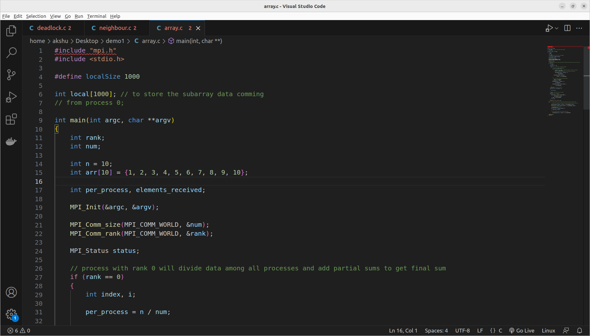

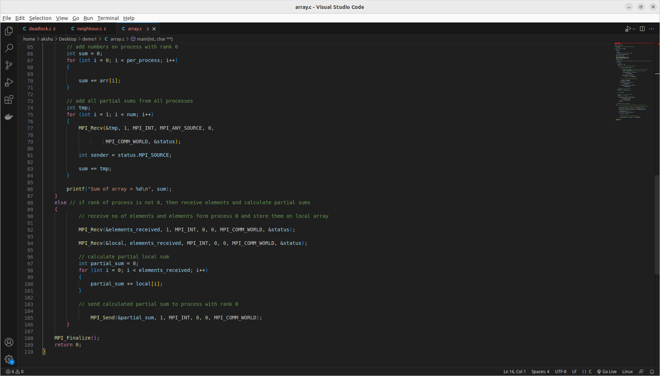

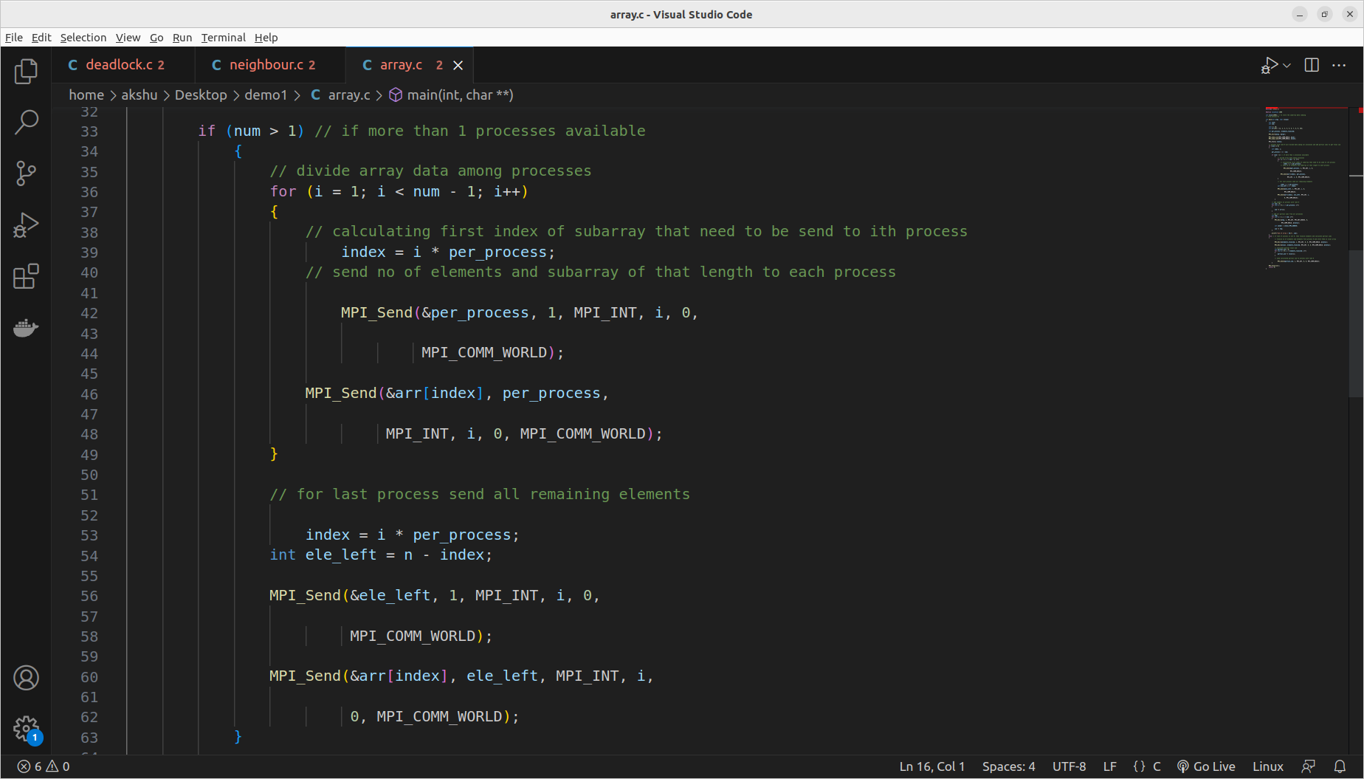

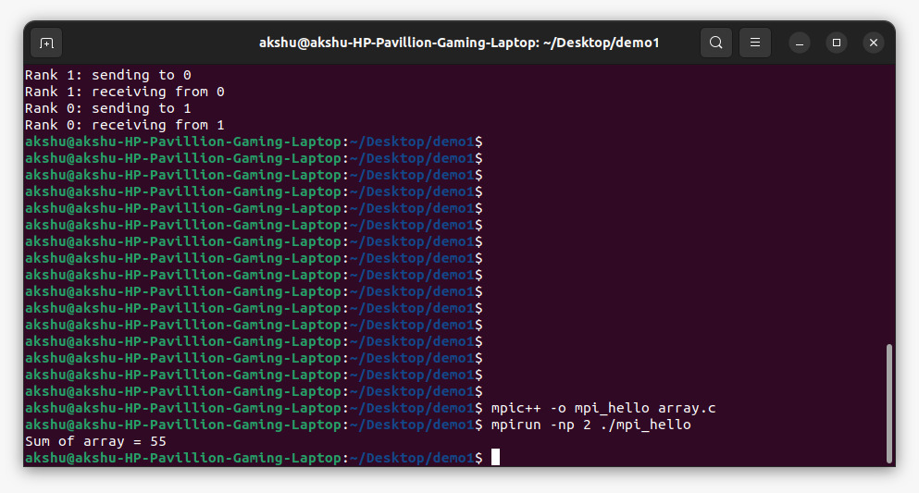

**GitHub Link:**

<https://github.com/Siddhish16/HPC-Assignments>